**SQL QUERIES FOR PIZZA SALES REPORT**

A.KPI

**1. Total Revenue:**

SELECT SUM(total_price) AS Total_Revenue FROM pizza_sales;

OUTPUT

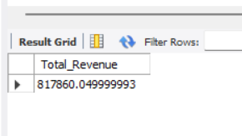

**2.Average Order Value:**

SELECT SUM(total_price) / COUNT(DISTINCT order_id) AS Avg_order_value FROM pizza_sales;

OUTPUT

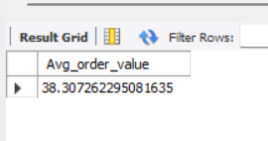

**3. Total Pizzas Sold:**

SELECT SUM(quantity) AS Total_Pizzaa_Sold FROM pizza_sales;

OUTPUT

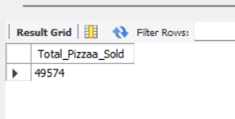

**4. Total Order:**

SELECT COUNT(DISTINCT order_id) AS Total_Orders FROM pizza_sales;

OUTPUT

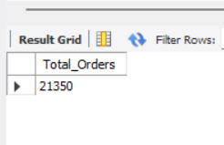

**5. Average Pizzas per Order:**

SELECT SUM(quantity) / COUNT(DISTINCT order_id) AS Ave_Pizzas_per_Order FROM pizza_sales;

OUTPUT

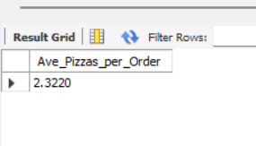

**A. Daily trends for total orders:**

SELECT DATENAME(DW, order_date) AS order_day, COUNT(DISTINCT order_id) AS total_orders FROM pizza_sales

GROUP BY DATENAME(DW, order_date)

OUTPUT

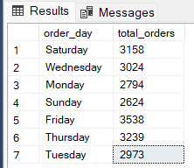

**B. Monthly trend for total orders:**

SELECT DATENAME(MONTH, order_date) as Month_Name, COUNT(DISTINCT order_id) as Total_Orders FROM pizza_sales

GROUP BY DATENAME(MONTH, order_date)

OUTPUT

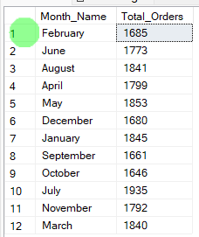

**C. Percentage of sales by Pizza cCtegory:**

SELECT pizza_category, CAST(SUM(total_price) AS DECIMAL(10,2)) as total_revenue,

CAST(SUM(total_price) * 100 / (SELECT SUM(total_price) from pizza_sales) AS DECIMAL(10,2)) AS PCT

FROM pizza_sales

GROUP BY pizza_category

OUTPUT

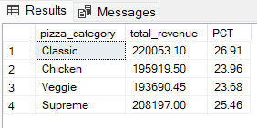

**D. Percentage of sales by Pizza Size:**

SELECT pizza_size, CAST(SUM(total_price) AS DECIMAL(10,2)) as total_revenue,

CAST(SUM(total_price) * 100 / (SELECT SUM(total_price) from pizza_sales) AS DECIMAL(10,2)) AS PCT

FROM pizza_sales

GROUP BY pizza_size

ORDER BY pizza_size

OUTPUT

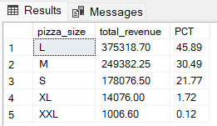

**E.Total Pizza sold by Pizza Category:**

SELECT pizza_category, SUM(quantity) as Total_Quantity_Sold

FROM pizza_sales

WHERE MONTH(order_date) = 2

GROUP BY pizza_category

ORDER BY Total_Quantity_Sold DESC

OUTPUT

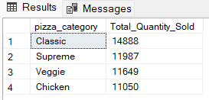

**F. Top 5 Pizza by Revenue:**

SELECT Top 5 pizza_name, SUM(total_price) AS Total_Revenue

FROM pizza_sales

GROUP BY pizza_name

ORDER BY Total_Revenue DESC

OUTPUT

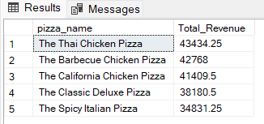

**G. Bottom 5 Pizza by Revenue:**

SELECT Top 5 pizza_name, SUM(total_price) AS Total_Revenue

FROM pizza_sales

GROUP BY pizza_name

ORDER BY Total_Revenue ASC

OUTPUT

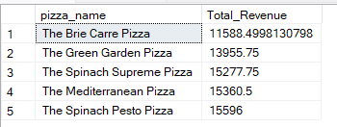

**H. Top 5 Pizza by Quantities:**

SELECT Top 5 pizza_name, SUM(quantity) AS Total_Pizza_Sold

FROM pizza_sales

GROUP BY pizza_name

ORDER BY Total_Pizza_Sold DESC

OUTPUT

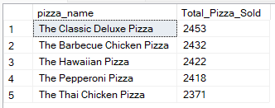

**I. Bottom 5 Pizza by Quantities:**

SELECT TOP 5 pizza_name, SUM(quantity) AS Total_Pizza_Sold

FROM pizza_sales

GROUP BY pizza_name

ORDER BY Total_Pizza_Sold ASC

OUTPUT

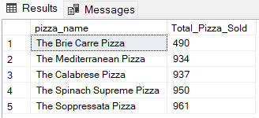

**J.Top 5 Pizzas by Total Orders:**

SELECT Top 5 pizza_name, COUNT(DISTINCT order_id) AS Total_Orders

FROM pizza_sales

GROUP BY pizza_name

ORDER BY Total_Orders DESC

OUTPUT

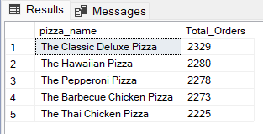

**K. Bottom 5 Pizzas by Total orders:**

SELECT Top 5 pizza_name, COUNT(DISTINCT order_id) AS Total_Orders

FROM pizza_sales

GROUP BY pizza_name

ORDER BY Total_Orders ASC

OUTPUT

